The General Data Protection Regulation, GDPR, replaces all previous Data Protection Directives that were in place. It was approved by the EU Parliament in 2016 and comes into effect on 25th May 2018.

GDPR states that personal data should be ‘processed fairly and lawfully’ and ‘collected for specified, explicit and legitimate purposes’ and that individuals data is not process without their knowledge and are only processed with their ‘explicit’ consent. GDPR covers personal data relating to individuals, Horsmonden Kindergarten is committed to protecting the rights and freedoms of individuals with respect to the processing of children’s, parents, visitors and staff personal data.

The GDPR Act gives individuals the right to know what information is held about them. It provides a framework to ensure that personal information is handled properly.

GDPR includes certain rights for individuals

- The right to be informed

Horsmonden Kindergarten is a registered Childcare provider with Ofsted and as such is required to collect and manage certain data.

Parent names, addresses, telephone numbers, email addresses, date of birth and National Insurance numbers are required.
Pupil names, addresses, date of birth and birth certificate numbers.
For parents claiming the free nursery entitlement this information is passed on to Kent County Council using a secure electronic file transfer system.

Horsmonden Kindergarten collects certain details from visitors to the premises, such as names, telephone numbers, addresses and if appropriate company names. This is required to fulfil our Health and Safety and Safeguarding Policies.

As an employer, Horsmonden Kindergarten is required to hold data on its employees; names, addresses email addresses, telephone numbers, date of birth, National Insurance numbers, photographic IK, bank details and next of kin details.

The Disclosure and Barring Service is used to check employees and volunteers for their suitability to work at the Kindergarten and the Kindergarten hold the certificate numbers following these checks.

- The right of access

At any point an individual can make a request relating to their data and Horsmonden Kindergarten will need to provide a response (within 1 month). Horsmonden Kindergarten can refuse a request, if we have a lawful obligation to retain data i.e. from Ofsted in relation to the EYFS, but we will inform the individual of the reasons for the rejection. The individual will have the right to complain to the Information Commissioners Office if they are not happy with the decision. The ICO can be contacted at Information Commissioners Office, Wycliffe House, Water Lane, Wilmslow, Cheshire, SK9 5AF or ico.org.uk/

- The right to erasure

Individuals have the right to request the deletion of their data where there is no compelling reason for its continued use. However, Horsmonden Kindergarten has a legal duty to keep children’s and parents details for a reasonable time (as specified in our Retention of Records Policy). The data is archived securely on site and shredded at the end of the legal retention period.

- The right to restrict processing

Parents, visitors and staff can object to Horsmonden Processing their data. This means that data can be stored but must not be used in any way. The use of photographs for example may be restricted using the Media Consent Form.

- The right to data portability

Horsmonden Kindergarten requires data to be transferred from one IT system to another. Examples of this include sharing information with Kent County Council, sharing information with parents using Tapestry. The information is transferred using secure file transfer systems.

- The right to object

Parents, visitors and staff can object to their data being used for certain activities like marketing.

- The right not to be subject to automated decision-making including profiling

These rights related to the use of automated decision-making where there is no human involvement and profiling is an automated system to evaluate things about an individual. Horsmonden Kindergarten does not use personal data for such purposes.

Storage and use of personal information

All paper copies of children’s and staff records are kept in a locked filing cabinet in the office at Francis Austen Memorial Hall, Back Lane, Horsmonden, TN12 8NJ.

Members of staff can have access to the children’s records, but information taken from these files is confidential. The records remain on site at Horsmonden Kindergarten at all times. The records are shredded at the end of the retention period.

Information about individual children is used in certain documents, such as a weekly register, medication forms, accident books, referrals to external agencies and disclosure forms. These records are shredded after the relevant retention period.

When a child leaves Horsmonden Kindergarten their data may be shared with the receiving school. Such information will be sent via a secure file transfer system, or the parent/carer will be given the data to deliver to the receiving school.

Horsmonden Kindergarten stores and uses personal data held visually in photographs or video clips or as sound recordings, provided the parent has given their permission via the relevant Media Consent Form.

Access to all office computers, drop box files and Tapestry Online Learning Journal is password protected.

Any portable data storage used to store personal data is stored in a locked filing cabinet.

This policy was adopted at a meeting of Horsmonden Kindergarten held during May 2018
Signed on behalf of Horsmonden Kindergarten

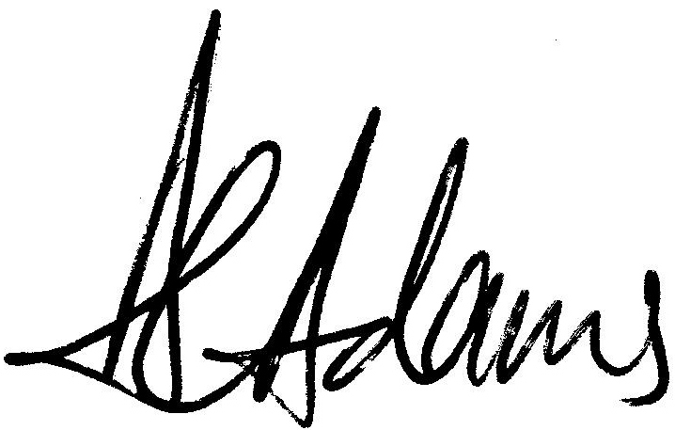
Alison Adams (Chairperson)

